CURICULUM VITAE

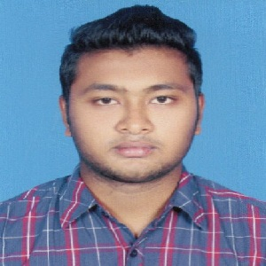
OF

Rahat Hossain Niloy.

Cell Phone: +8801677151288.
e-mail: rahathossain1414@gmail.com
Mailing Address: 84/24-Kha, North Vashantek,
Dhaka Cantt., Dhaka-1206.

CAREER OBJECTIVE

To prove myself as a quick learner and highly energetic person to face any challenge in such an organization. Also wants to apply my talents, knowledge and courage in Research and Development to create some authentic and novel technologies that meets the cutting edge technological demand of the modern World.

 | ACADEMIC QUALIFICATION
Honors
Institution |  |  | Govt. Titumir College, Dhaka
Subject |  |  | Marketing
Result |  |  | Running (3rd Year)
Board |  |  | Under Dhaka University
H.S.C
Institution |  |  | B.A.F Shaheen College, Dhaka.
Group |  |  | Business Studies
Result |  |  | GPA-4.42
Pashing Year |  | 2017
Board |  |  | Dhaka
S.S.C
Institution |  |  | Bhashantek High School.
Group |  |  | Business Studies
Result |  |  | GPA-4.39
Passing Year |  | 2015
Board |  |  | Dhaka

 | Experiences
Period | February 2018 to April 2018
Position | Executive
Company | Kites International Trade & Exhibitions Pvt. Ltd
Period | July 2018 to February 2019
Position | Customer Service Associate (CSA)
Company | Genex Infosys Ltd.
Period | April 2019 to Running
Position | Call Center Executive
Company | Supernova Techno Ltd

Language Skill | Reading | Writing | Speaking
Bangla | Excellent | Excellent | Excellent
English | Good | Good | Good

DECLARATION

I am swearing of such way that all the above information and included documents are correct and true. If any of these wrong and false, I abide by any order and punishment by authority.


 | PERSONAL INFORMATION
Name | Rahat Hossain Niloy.
Father’s Name | Md. Jamshed Molla
Mother’s Name | Sajada Parvin
Present Address | 84/24-Kha, North Vashantek,
 | Dhaka Cantt., Dhaka-1206.
Permanent Address | 84/24-Kha, North Vashantek,
 | Dhaka Cantt., Dhaka-1206.
Date of Birth | 08-05-1999
Sex | Male
Religion | Islam
Marital Status | Un-married
Nationality | Bangladeshi (By Birth)
Height | 5’-6”
Weight | 60 kg

Date: .......................... Md. Rahat Hossain Niloy

